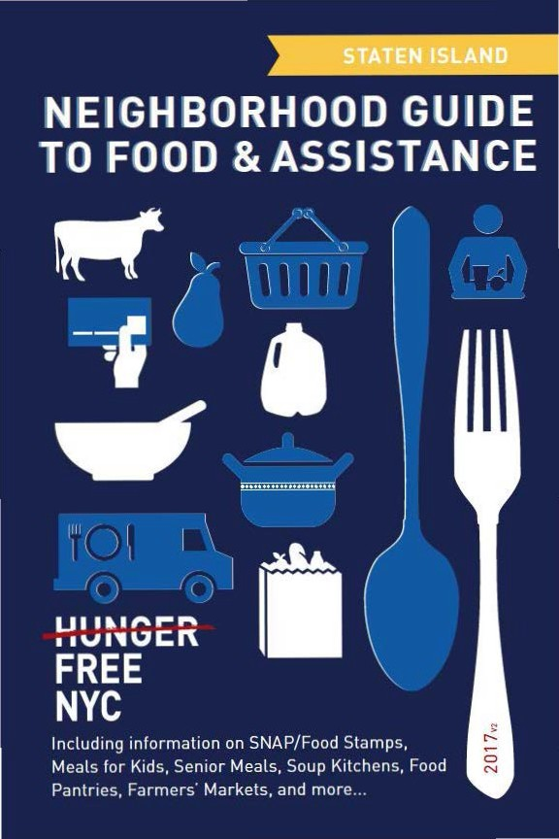

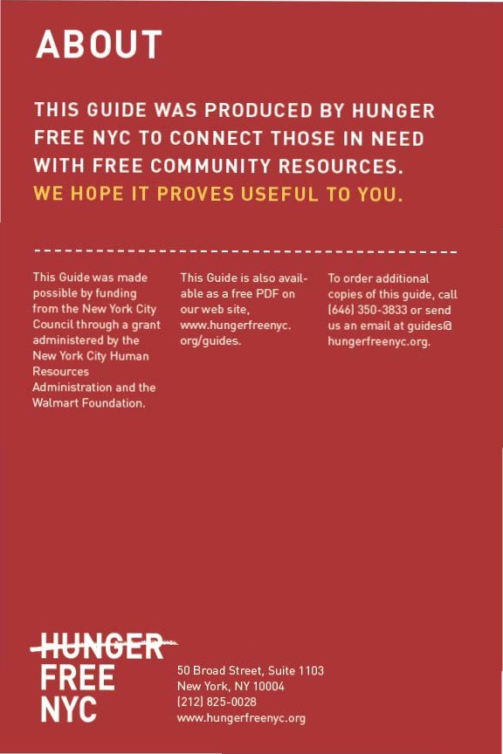

CON TEN TS

Food Stam ps/SNAP 4
6) Food fo r Kids B
e Em ployme nt & Tra ini ng 10
<D Senior Mea ls 11
0- Soup Ki tch ens & Food Pantries 12
e From the Farm 18
Map of Locations 20
Other Assista nce 22
Emergency N um bers 23

Neighborhood Guide to Food and Assistance - StatenIsland Edition
 SNAP/
FOOD STAMPS
SNAP benefits, the new name for food stamps, can help put healthy food on the table by providing monthly assistance
to purchase food at authorized grocery stores and farmers' markets. Benef its are provided monthly th rough a plastic benef it card, similar to a de bit or credit card.



EBT
Stands for Electronic Benefit Transfer. It's the system the goverment uses to disburse benefits.

SNAP
Stands for
Supplemental Nutrition Assistance Program. "SNAP benefits" is the same thing as ..food stamps."

WHAT SHOULD I KNOW?

ID Employment does not interfere with getting SNAP.Even if you a re working, but earning lowwages, you may be eligible.
ID Average SNAP benefits a re over $100 per person per month, and $250 or more
for families. That mea ns that SNAP benef its for the average family receiving them totals more than $3,000 worth of food support
each year.
ID Farmers' markets often accept SNAP benefits, so you ca n purchase fresh produce and food-producing seeds and plants using your benefits. For a complete list of farmers' markets that accept them , see page 18.

IINeighborhood Guide to Food and Assistance ·Staten Island Edition

AM I ELIGIBLE?


Eligibility is based on household size, income, expenses and other factors. Households have to meet income tests to receive benefits, but households that have members w ho are disabled or elderly (60 or older), or have out-of-pocket expenses for child care or dependant ca re, ca n have higher incomes a nd still be eligible.
.

NUMBER OF PEOPLE
A
MONTHLY INCOME LIMIT
1
IN HOUSEHOLO | (PRE-TAXES] |  | SNAP BENEFITS
1 | $1 ,307 |  | $192
2 | $1 ,760 |  | $352
3 | $2,213 |  | $504
4 | $2,665 |  | $640

MAX.MONTHLY
2

Each additional household member
+$453
(approximately)
+ $144
(approximately)

11n effect
10/1/16 - 9/30/17.

21n effect
10/1/16 - 9/30/17.

If you meet the above income qualifications, it doesn't matter how much money you may or may not have in countable resources. In other words, you can save money for education, a home purchase, or retirement a nd still receive SNAP benefits.

Neighborhood Guide to Food and Assistance - Staten Island Edition II

IMMIGRANT ELIGIBILITY

Legal immigrants can often receive SNAP benefits if they:
- have lived in the country for 5 years or more; or
- are children (under age 18).
Ineligible immigrant parents can still receive benefits for their children even if a parent does not qualify.
Certain non-citizens, such as those admitted for humanitarian reasons, may also be able to receive benefits.
Immigration status is not negatively affected if you apply for or receive SNAP benefits.

HOW TO APPLY

Apply at Select Community Organizations
1

Call either of the below numbers to see if you may be eligible for benefits. If so, you’ll be offered an appointment at an agency in your community, where you’ll receive help in submitting your application electronically.
Hunger Free NYC
646 355 1475 & 646 350 1104

Neighborhood Guide to Food and Assistance - Staten Island edition
6

ACCESSNYC
2
SNAP/FOOD STAMPS

Apply online at: www.nyc.gov/accessnyc

Visit Your Local HRA Office
3

Apply at a SNAP office near you:

1 Richmond SnaP Center
201 Bay St., 1st Floor, 10301
718 722 8013
Mon-Fri 8:30am-6pm, Sat 9am-5pm

You can also call 718 557 1399 to find a SNAP office near you and for information about qualifications, guidelines, and applications.
I)FOOD FOR KIDS
WOMEN, INFANTS & CHILDREN
WIC is the Women, Infants & Children Program.
QUICK FACTS
ID WIC is for low-income pregnant women, breast-feeding women, and women with children under the age of five.
ID You can work and still get WIC.
ID You can continue to get cash assistance or SNAP benefits/food stamps while receiving WIC.
ID You can get WIC even if you are undocumented or not a citizen.

HOW TO APPLY
To find the WIC off ice nearest you call 800 522 5006, call 866 3-H UN G RY or v isit these local WIC off ices.
- Richmond University Medical Center 355 Bard Ave.. 10310
718 818 2373
Mon-Fri 9am-3pm
- Northwell Health Physician PartnersWIC Program - Bay Street 57 Bay Street., 2nd Floor, 10301
718 226 5235
Mon-Fri 9am-5pm
- Richmond University Medical Center- Mid-Island WIC 1775 Richmond Ave., 10314
718 8182372
Wed 9:30am-1 :30pm

IINeighborhood Guide to Food and Assistance· Staten Island Edition
- northwell Health Physician Partners WIC Program - SIUH
475 Seaview Ave., 10305
FOOD FOR KIDS
718 226 6270
Mon-Fri 9am-5pm
- Staten Island University Hospital South WIC Program
375 Sequine Ave, 10309
718 226 2461
Wed 8am-4pm

SCHOOl & SUMMeR Meal S

SFSP is the Summer Food Service Program, also known as Summer Meals.
QUICK FaCtS
During school, free breakfasts are available to all children regardless of income, with no paperwork required.
Many public school students are also eligible for free or reduced price lunch. An application may be required.
Eligibility for school meals is not impacted by immigration status.
In June, July and August, lunch and breakfast are served for free to all children under 19 at many public schools, houses of worship, recreation centers, and community centers - no application or registration required.
Visit www.schoolfoodnyc.org for more information about school breakfast, school lunch, and summer meals. For nearby summer meals sites, text FOOD to 877-877, call 311, or call the National Hunger Hotline at 866 3-HUNGRY.
A JOB TRAINING &
RESOURCES
Certain individuals may be required to be employed, seeking employment and I or enrolled in a tra ining program in order to receive SNAP benefits.

EMPLOYMENT & TRAINING

Visit the follow ing sites to find out more about training and education programs across the city:

www1 .nyc.gov/htmVsbs/wf1/html/develop/develop.shtml www1 .nyc.gov/site/h ra/help/types-trai ning-ed ucation.page

eSENIOR MEALS
MEALS AT SENIOR CENTERS
Senior centers often serve meals for older people. Some centers offer free meals, oth ers ask for a small contribution !from fifty cents up to a few dollars!. This contribution may be voluntary or required. Senior cen ters and other sites with food for seniors are marked with • in the Soup Kitchens and Food Pantries section.
FIND YOUR LOCAL SENIOR CENTER
Call 311 and be prepared to provide your ZIP code to the operator.

MEALS- ON- WHEELS PROGRAM
If you are homebound and over the age of 60, you can receive home-delivered meals up to 7 days a week. Household income does not
affect eligibility.
HOW TO APPLY
To request meals-on-wheels service , call yourlocal case management agency.
To find the appropriate agency, contac t the Citymeals-on-Wheels' Program Department at 212 687 1234 or the National Hunger Hotline at 866 3-HUNGRY.
Nelghbomood Gulde to Food and Assistance·StatenIsland Edition
OUP KITCHENS OFOOD PANTRIES
Agencies listed as sou p kitchens provide prepared meals during
their listed serving times, wh ile agencies listed as food pantries provide bags of food to be prepared at home.
Whilewe try to keep this list as accurate and up-to-date as possible, we recom mend calling the agency before going to confirm their schedule. Some agencies require a referral, I D, or proof of address. To conf irm, contact the agency directly, call the NYC Emergency Food Line at 866 888 8777 or call the National Hu nger Hotline at 866
3HUN GRY. Agencies ma rked with •are senior centers and/or provide food specifically for seniors.
NORTH SHORE
10303, 10302, 10310
- City Harvest Mariner's Harbor Mobile Market Basketba ll court at 22 Rockbury St., 10303 646 412 0600
Mobile Market Pantry:1st Wed, 3rd Sat 9:30am-11 :30a m
Open only to residents of the Mariner's Harbor Houses, Todt Hill or West Brighton Houses, Arlington Terrace Apartments, Zip codes 10302, 10303,10310 and 10314 only. All food is fresh fru its
and vegetables. Families mu st reg ister to pa rticipate - bring proof of address a nd a photo ID. For further information on registration please call 646 412 0743. For information on available produce
and dates of d ist ribut ion , please call the MobileMa rket Hotlin e at 866 444 0244.
- Project Hospitality Mobile Pantry - St. Michael's Church 207 Harbor Road, 10303
Food Pantry: 4th Sun 1:OOpm Come on time, pa ntry is mobile.
- Catholic Charities Mobile Food Pantry - anderson avenue
PANTRIES & KITCHENS
120 Anderson Avenue, 10302
718 448 5757 x17
Mobile Food Pantry: tue 1pm-3pm
- Faith United Methodist Church
221 Heberton Ave, 10302
718 442 5684
Food Pantry: Call for an appt. Ask for Bill or Norcie Morris
- Project Hospitality - el Centro de Hospitalidad
1546 Castleton Ave, 10302
718 815 5538
Food Pantry: thu 4pm-5:30pm, Sat 9am-10:30am Please bring your own bags.
- Community Health action of Staten Island
2134 Richmond Terrace, 10302
718 808 1870
Food Pantry: tue 10am-2pm (Seniors' Day), Wed 12pm-4pm,
Fri 2pm-6pm, Sat 10am-2pm
Photo ID and proof of family size required. Please bring bags as they are not always available.
- Rescue Ministries/Ministerio Rescate
2083 Richmond Terrace, 10302
718 448 4454
Soup Kitchen: tue, thu 11:30am-1pm Food Pantry: tue, thu 8:30am-1pm Closed major holidays.
- Salvation army Port Richmond Corps
1295 Forest Ave, 10302
718 442 2145 x203
Soup Kitchen: tue-thu 11:30am-1pm
Food Pantry: Mon, tue, thu 10am-2pm
Photo ID and proof of address required. Appointment necessary
- pick up is once/month. Serves zip codes 10301-10303, 10310, 10311, 10313, 10314.
- Project Hospitality Mobile Pantry - Shiloh aMe Zion Church
779 Henderson Ave., 10310
718 447 0261
Food Pantry: 1st Sun 1:00pm Come on time, pantry is mobile.
St. GeORGe, StaPletOn, tHe HIllS
10301, 10304, 10314
- Catholic Charities Mobile Food Pantry at St. Peter's Church
53 St. Mark's Place, 10301
718 448 5757
Mobile Food Pantry: tue 1pm-2pm
- Council of Jewish Organizations
382 Jersey St., 10301
718 720 4047
Food Pantry: Mon, tue, thu, Fri 10am-2pm ID and proof of residence required.
- new Brighton Church of God in Christ
386 Jersey Street, 10301
Food Pantry: Sat 10am-1pm
ID preferred. One bag of food per family.
- Project Hospitality Mobile Pantry - Jersey St. & Benziger ave.
Jersey St. & Benziger Ave., 10301 Food Pantry: Mon 12:30pm Come on time, pantry is mobile.
- Our lady of Good Counsel Church
42 Austin Place, 10304
718 447 1503
Food Pantry: Sat 10am-11am
Photo ID and proof of address for household members required first time.
- trinity lutheran Church
PANTRIES & KITCHENS
309 St. Pauls Ave., entrance at 175 Beach St., 10304 718 447 0526
Food Pantry: Sat 11am-1 pm
Soup Kitchen: Sat 12pm-1 pm
- Project Hospitality 514 Bay St., 10304 718 815 0800
Soup Kitchen: tue, thu 12pm-1pm
Food Pantry: tue 9am-11am, 1pm-3pm; thu 9am-11am Photo ID and proof of address required, bring your own bags.
- United Church of Praise Healthy Heart
32 Sands Street, 10304
Food Pantry: Sun, Fri 1pm-3pm
ID and proof of address for family members required.
- Project Hospitality Mobile Pantry - Family Restoration Ministries
70 Beach St., 10304
Food Pantry: 3rd Sun 9:30am Come on time, pantry is mobile.
- Salvation army Stapleton 15 Broad Street, 10304 718 448 8480
Soup Kitchen: Mon, Fri 11:30am-1pm
Food Pantry: tue-thu 12:30pm-3pm by appointment (appt. not needed first visit).
ID with proof of address required. Closed all major federal holidays.
- Catholic Charities/Rusty Staub Mobile Food Pantry at Immaculate Conception Church
128 Targee St., 10304
718 447 6330
Food Pantry: tue 10am-11am
- Stapleton Union aMe Church
49 Tompkins Ave, 10304
718 273 2857
Soup Kitchen: Mon 3pm-4pm, Wed 12pm-1pm
Food Pantry: tue, Fri 10am-1pm
ID required for all household members for pantry. Kids afterschool program Tue, Wed 3pm-5pm with pantry bag to take home after. Clothing distribution Thu 7am.
- City Harvest Stapleton Houses Mobile Market
Tennis Courts behind 75 Hill Street in Stapleton Houses, 10304 866 444 0244
Mobile Pantry: 1st tue, 3rd Sat 9:30am-11:30am
Open only to participants in programs at the Stapleton Houses Sr Ctr, those w/ a student at IS 49, residents in Berry, Cassidy Coles, New Lane, Richmond Terrace, South Beach, or Stapleton Houses, or residents of 10301, 10304, 10305, 10310. All food is fresh fruits and vegetables. Families must register to participate
- bring proof of address and a photo ID. For further information on registration please call 646 412 0743. For information on available produce and dates of distribution, please call the MobileMarket Hotline at 866 444 0244.
- Project Hospitality Mobile Pantry - Vanderbilt ave. Moravian Church
285 Vanderbilt Ave., 10304
Food Pantry: thu 12:30pm Come on time, pantry is mobile.
- Project Hospitality Mobile Pantry - african Refuge Center
185 Park Hill Ave., 10304
Food Pantry: Wed 12:30pm Come on time, pantry is mobile.
- Staten Island liberian Community 180 Park Hill Ave., Lobby C, 10304 718 496 7492
Food Pantry: Wed 2pm-4pm ID preferred.
- Christian Pentecostal Church
PANTRIES & KITCHENS
910 Richmond Rd. (entrance in rear), 10304 718 273 5850
Food Pantry: tue, Wed 6pm-8pm
Photo ID required for registration. Serves residents of Staten Island.
- all Saints Church episcopal Ministry
2329 Victory Blvd., 10314
718 698 1338
Food Pantry: Mon-Wed, Fri 10am-12pm
- Jewish Community Center of Staten Island
1466 Manor Rd., 10314
718 475 5242
Food Pantry: Mon-thu 10:30am-6:30pm; Fri 10am-12pm All pantry pick-up by appointment only, ID required.
eaSt and SOUtH SHORe
10306, 10309, 10307
- Project Hospitality Mobile Pantry - Our lady of lourdes Chapel
130 Cedar Grove Ave., 10306 Food Pantry: 3rd Sun 10:30am Come on time, pantry is mobile.
- St. edward's Food Pantry 6581 Hylan Blvd., 10309 718 984 1625
Food Pantry: Mon, Wed, Sat 10am-1pm
Photo ID, proof of address and proof of household required first time. Can come to pantry once every two weeks.
- St. Paul's Methodist Church South Shore Food Pantry
7558 Amboy Road, 10307
718 227 2485
Food Pantry: Wed, thu 9am-1pm
Call first for appointment. Proof of address required.
- Project Hospitality Mobile Pantry - St. Stephen's episcopal Church
7516 Amboy Rd., 10307
Food Pantry: 2nd Sun 1:00pm Come on time, pantry is mobile.
eFROM THE FAR M
New Yorkers can access foods straight from the farm in two ways: farmers' markets and community su pported ag riculture programs or CSAs.

FARMERS' MAR KETS
All farmers' markets listed accept EBT/SNAP (food stamps).

- St. George Greenmarket
Hyatt St. & St. Mark's Place, 10301
Sat 8am-2pm, year round
- Staten Island Mall Greenmarket Marsh Ave. and Ring Rd., 10314 Sat 8am-3pm, May 6-Dec 23

IINeighborhood Guide to Food and Assistance - StatenIsland Edition
CSA PROGRAMS

CSA members purchase "shares" in an entire season of high quality, fresh produce grown by local farmers. Members usually pay for their shares in advance, but some CSAs adjust payment to income, ac- cept SNAP benefits, and allow some members to pay week to week. Members typically pick up boxes of produce from a set location every week though some CSAs have half-shares available for pick up every other week.
FROM THE FARM
Note that sign up is generally March to May, with the first pickup in June or July and the last one in late October or early November. As a rule, late sign up is not permitted. Some CSAs also have limited winter shares.
Corbin Hill
Multiple pickup locations. Allows signups Tuesday/Wednesday before first pickup. Permits weekly payment and payment via SNAP. Weekly in summer, every other week in winter. Reduced price shares available. Visit Corbin Hill's website, call, or email to find a CSA program near you and sign up.
Contact: info@corbinhillfarm.com, 646 254 2250
Web: www.corbinhillfoodproject.org/new-farm-share/

Just Food
Multiple pickup locations. Sign up deadlines and SNAP acceptance vary. Winter shares available from some CSAs. Visit Just Food's website, call, or email to find a CSA program near you. Contact the CSA directly to sign up.
Contact: info@justfood.org, 212 645 9880
Web: www.justfood.org/csaloc
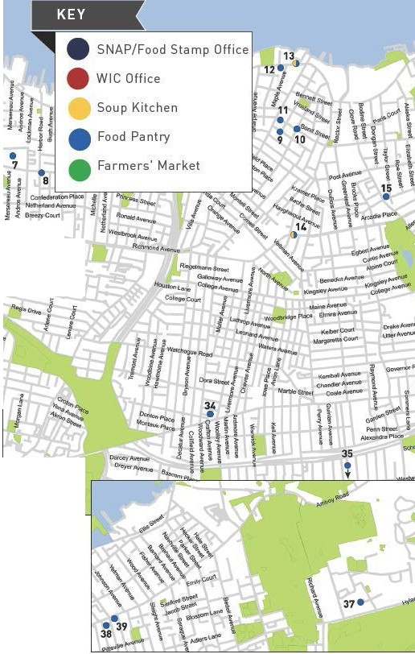

J
1 1J 1
! J l
"'

4 41
- i
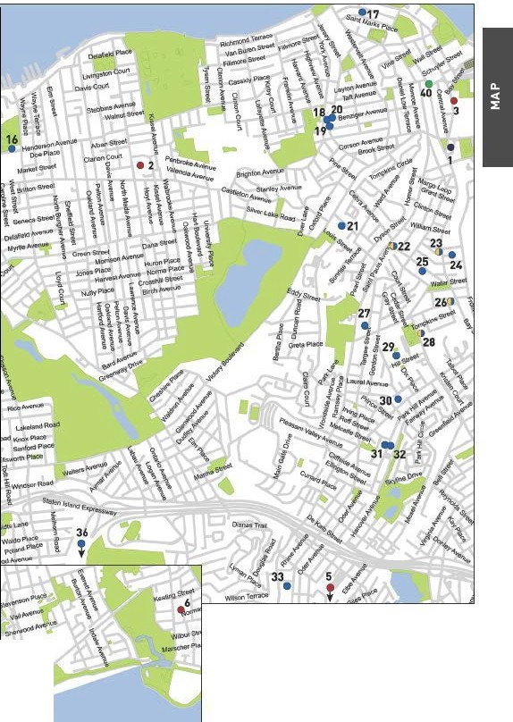

\
\

II
OTHER ASSISTANCE
Additional organizations in your neighborhood that can as- sist you with matters other than food support.

MEDICAL CARE

Staten Island University Hospital north
475 Seaview Ave., 10305
718 226 9000
Staten Island University Hospital South
375 Seguine Ave., 10309
718 226 2000
Stapleton Family Health Center
111 Canal St., 10304
718 390 0712
Marine Harbor Family Health Center
2040 Forest Ave., 10303
718 761 2060
Richmond University Medical Center
355 Bard Ave., 10310
718 818 1234
Community Health Center of Richmond
235 Port Richmond Ave., 10302
718 876 1732

HEALTH INSURANCE

Affinity Health System
Information regarding health insurance, including enrollment in Medicaid, Medicare and other plans.
General Info 866 694 9809

Neighborhood Guide to Food and Assistance - Staten Island edition
22

Provides specific and detailed assistance regarding a wide range of legal topics, including agencies that might be able to help you find an attorney to represent you in court.
LEGAL ASSISTANCE
The City Bar Justice Hotline
212 626 7383
Mon–Thu 9am-5pm, Fri 9am-1pm
Free, basic legal advice on a range of civil issues. Will not provide an attorney or assist with in-court representation.
X
MORE HELP
EMERGENCY NUMBERS

National Hunger Hotline 866 3-HUNGRY (866 348 6479)
NYC Hunger Hotline 866 888 8777 Police, Fire or Ambulance: 911 Emergency Shelter: 311
Homeless Hotline: 800 994 6494, 212 533 5151
Immigration Hotline: 212 419 3737, 800 566 7636
Center for Disease Control: 800 232 4636
Poison Control: 800 222 1222
AIDS Hotline: 800 541 AIDS, 800 233 7432 (Spanish)
Alcoholics Anonymous: 212 647 1680
Narcotics Anonymous: 212 929 6262
Gamblers Anonymous Hotline: 855 222 5542
Domestic Violence Hotline: 800 621 4673
Battered Women Hotline: 718 499 2151
Rape & Sexual Assault Hotline: 212 423 2140, 212 227 3000
Child Abuse Hotline: 800 342 3720
Runaway Hotline: 800 786 2929 (800 RUN AWAY)
Crime Victim Hotline: 212 577 7777, 800 689 4357
Suicide Hotline: 800 273 8255
National Crisis Line: 800 999 9999

Credits: Icons adapted from The Noun Project collection. Map data © OpenStreet- Map contributors.

Neighborhood Guide to Food and Assistance - Staten Island edition
23
WHAT AM I ELIG IBLE FOR ?

Use the chart below to see what programs may be available for you and your family.
e CD 0


PEOPLE WITH CHILDREN
e 0

PEOPLE WITHOUT CHILDREN
e a> 0

SENIOR CITIZENS
e CD 0

HOMELESS INDIVIDUALS

LEGAL IMMIGRANTS
e CD 0

UNDOCUMENTED IMMIGRANTS
() 0

A SNAP/ Food Stamp 0Groceries at Food Pantries WIC Packages
'1Benefits
School Breakfast & Lunch - Meals at Soup Kitchens
W Free Summer Meals for Children
/IP\ Meals at Senior Centers
\ii Home-delivered Meals
-IU:JN6ER

FREE
NYC
Have any suggestions on how to make this Guide better? Email gu ideslilhu ngerf reenyc.org.

